Topic 4 :

# Lesson 1: Operators

# In this lesson we will learn about Operators.

# So,

# What is operators ?

# Operators are symbols that perform operations on variables and values.



Operators in Java can be classified into 5 types:

1. Arithmetic Operators
2. Assignment Operators
3. Relational Operators
4. Logical Operators
5. Unary Operators
6. Bitwise Operators
7. **Java Arithmetic Operators .**

* Arithmetic operators are used to perform arithmetic operations on variables.

Example –

1.) a+b :- here ‘+’ operators is used to add two variables named a and b.

2.) a-b :- Here ‘-’ operators is used to subtract two variables a and b.

3.) a%b :- This ‘%’ is called **Modulus** operator. The modulus operator returns the remainder of the two numbers after division.

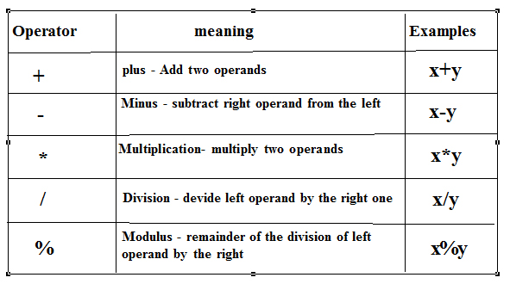

1. **Java Assignment Operator .**

Here, ‘ **=** ’ is the assignment operator. It assigns the value on its right to the variable on its left.

*Example*–

int number = 29

1. **Java Relational Operators .**

**Relational Operators** in java are used to comparing two variables for equality , non- equality , greater than, less than etc.

